# Lab: Iterators and Comparators

This document defines the exercises for the "Java Advanced" course @ SoftUni.

Please submit your solutions (source code) to all below-described problems in [Judge](https://judge.softuni.org/Contests/4020/Iterators-and-Comparators-Lab-MLC)

## Book

Create a class **Book** from the **UML diagram** below:

|  |  |
| --- | --- |
| **Book** | |
| - | title: String |
| - | year: int |
| - | authors: List<String> |
| - | setTitle(String) |
| - | setYear(String) |
| - | setAuthors(String…) |
| + | getTitle(): String |
| + | getYear(): int |
| + | getAuthors(): List<String> |

You can use only **one constructor**. There **can be no authors**, **one author,** or **many authors**.

### Examples

|  |
| --- |
| Main.java |
| **public static void** main(String[] args) {  Book bookOne = **new** Book(**"Animal Farm"**, 2003, **"George Orwell"**);  Book bookThree = **new** Book(**"The Documents in the Case"**, 2002);  Book bookTwo = **new** Book(**"The Documents in the Case"**, 1930, **"Dorothy Sayers"**, **"Robert Eustace"**);  List<Book> books = **new** ArrayList<>(); books.add(bookOne); books.add(bookTwo); books.add(bookThree);  } |

### Solution

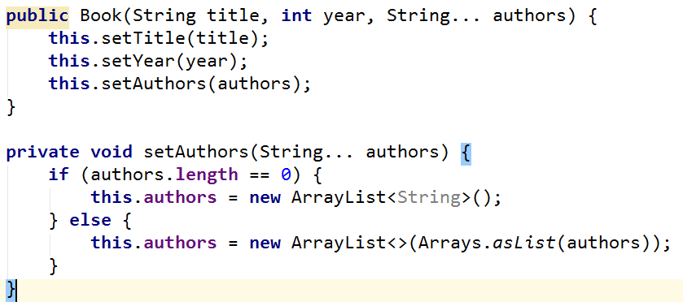

## Library

Create a class **Library** from the **UML diagram** below:

|  |  |
| --- | --- |
| **<<Iterable<Book>>>**  **Library** | |
| - | books: Book[] |
| + | iterator(): Iterator<Book> |

Create a **nested class** **LibIterator** from the **UML diagram** below:

|  |  |
| --- | --- |
| **<<Iterator<Book>>>**  **LibIterator** | |
| - | counter: int |
| + | hasNext(): boolean |
| + | next(): Book |

### Examples

|  |
| --- |
| Main.java |
| **public static void** main(String[] args) { Book bookOne = **new** Book(**"Animal Farm"**, 2003, **"George Orwell"**);  Book bookThree = **new** Book(**"The Documents in the Case"**, 2002); Book bookTwo = **new** Book(**"The Documents in the Case"**, 1930, **"Dorothy Sayers"**, **"Robert Eustace"**);  Library library = **new** Library<>(bookOne, bookTwo, boоkThree);  **for** (Book book: library) {  System.***out***.println(book.getTitle()); }  } |

### Solution

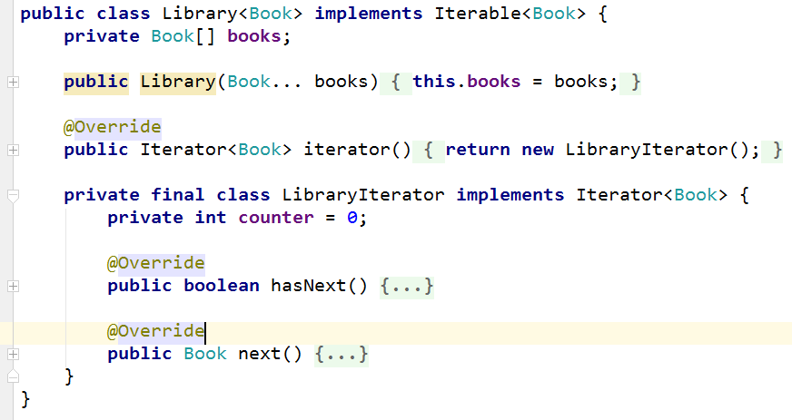

## Comparable Book

Expand Book by implementing **Comparable<Book>.**

The book has to be **compared by title**. When the title is equal, **compare** them by **year.**

Expand **Book** from **UML diagram** below:

|  |  |
| --- | --- |
| **<<Comparable<Book>>>**  **Book** | |
| - | title: String |
| - | year: int |
| - | authors: List<String> |
| - | setTitle(String) |
| - | setYear(String) |
| - | setAuthors(String…) |
| + | getTitle(): String |
| + | getYear(): int |
| + | getAuthors(): List<String> |
| + | **compareTo(Book): int** |

You can use only **one constructor**. There **can be no authors**, **one author,** or **many authors**.

### Examples

|  |
| --- |
| Main.java |
| **public static void** main(String[] args) { Book bookOne = **new** Book(**"Animal Farm"**, 2003, **"George Orwell"**); Book bookThree = **new** Book(**"The Documents in the Case"**, 2002); Book bookTwo = **new** Book(**"The Documents in the Case"**, 1930, **"Dorothy Sayers"**, **"Robert Eustace"**);  **if** (bookOne.compareTo(bookTwo) > 0) {  System.***out***.println(String.*format*(**"%s is before %s"**, bookOne, bookTwo)); } **else if** (bookOne.compareTo(bookTwo) < 0) {  System.***out***.println(String.*format*(**"%s is before %s"**, bookTwo, bookOne)); } **else** {  System.***out***.println(**"Book are equal"**); }  } |

## Book Comparator

Create a class **BookComparator** from the **UML diagram** below:

|  |  |
| --- | --- |
| **<<Comparator<Book>>>**  **BookComparator** | |
| + | **compare(Book, Book): int** |

**BookComparator** has to **compare** two books by:

1. Book title.
2. Year of publishing a book.

### Examples

|  |
| --- |
| Main.java |
| **public static void** main(String[] args) { Book bookOne = **new** Book(**"Animal Farm"**, 2003, **"George Orwell"**); Book bookThree = **new** Book(**"The Documents in the Case"**, 2002); Book bookTwo = **new** Book(**"The Documents in the Case"**, 1930, **"Dorothy Sayers"**, **"Robert Eustace"**);  List<Book> books = **new** ArrayList<>(); books.add(bookOne); books.add(bookTwo); books.add(bookThree);  books.sort(**new** BookComparator());  **for** (Book : books) {  System.***out***.println(book.getTitle() + book.getYear()); }  } |